**Canvas App User Guide**

* Download the Power Apps Mobile
* Login to the Power Apps Using the Office 365 Credential (used ObservationCaptureU1 to login).
* Use the User Name (Any String) ,Password (Any String) to loggin into the Canvas App

* In the Home Screen User can be to add New Observation by Clicking the + Symbol
* User can Search observation by title ,Location
* User can Edit the Observation Using Pencil Symbol on each Reccord.
* User can Log Out using the leave Icon

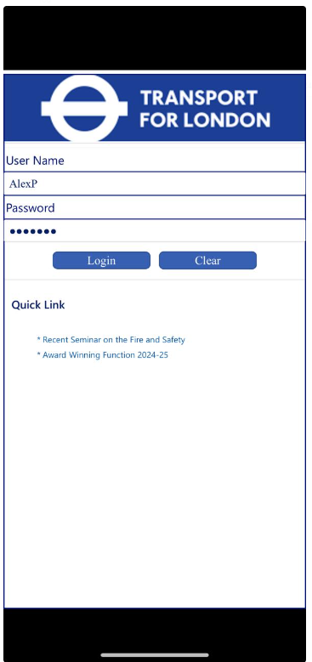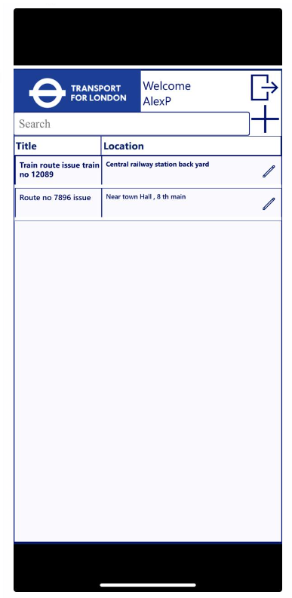

**Creating the Observation**

* Click on the + Symbol
* Enter Observation title, Observation Location, Description, Toggle on is safety critical
* User can submit to Submit Observation without Photo Or user can select Submit and Capture to capture Photo Or user can Select Submit and Upload to Select the Existing Photo
* Users can Modify the values and use the Update Button to update Observation .
* After Photo captured the records will be submitted to Dataverse submitted will be appears on the Observation records gallery.

